**ST. MARCELINO ACADEMY-MATUGGA**

**END OF AUGUST HOME STUDY ASSESSMENT**

**SUBJECT: LITERACY B (SST)**

**CLASS: PRIMARY TWO**

**NAME: …………………………………………………..……... STREAM: …………**

1. **Name these people found at school.**

|  |  |  |  |
| --- | --- | --- | --- |
|  |  |  |  |
|  |  |  |  |

1. **Tick three school symbols.**

school badge, library, school signpost, store keeper, school motto

1. Why do people build houses?

_________________________________________________________

1. Write down three people found at school.

i)__________________________ ii)__________________________

1. A __________________________ guards our home.
2. **Draw these building materials.**

|  |  |  |
| --- | --- | --- |
|  |  |  |
| **nails** | **sand** | **timber** |

1. Who heads a school?

_________________________________________________________

1. **Match people to their places of work.**

teacher garden

doctor shop

shopkeeper school

farmer hospital

1. Name the natural source of light.

_________________________________________________________

1. **Complete the table.**

|  |  |
| --- | --- |
| **Member** | **Role** |
| ______________________ | pays school fees |
| mother | ___________________________ |
| sister | ___________________________ |

1. Why do we need cooks at school?

_________________________________________________________

1. **Name the parts of the house.**

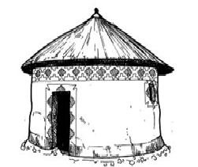

**C**

**A**

**B**

A ________________________ B ________________________

C ________________________

1. Mention two bad habits done by children at school.

i)________________________________________________________

ii)_______________________________________________________

1. **Name these types of weather.**

|  |  |
| --- | --- |
|  |  |
|  |  |

1. Outline two activities pupils do at school.

i)_______________________________________________________

ii)______________________________________________________

1. **Draw these things used in communication.**

|  |  |
| --- | --- |
|  |  |
| **bell** | **drum** |

1. Identify one animal used for transport.

_________________________________________________________

1. What is the motto of your school?

_________________________________________________________

1. Mention two things we use to keep peace and security.

i)___________________________ ii)__________________________

1. **Name the things we make.**

 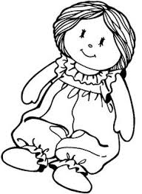 

______________ _____________ ____________

1. Who died for our sins?

_________________________________________________________

1. a) Write two Christian names.

i)___________________________ ii)__________________________

b) Write one Moslem name.

_________________________________________________________

1. **Draw these things found in church.**

|  |  |
| --- | --- |
|  |  |
| **cross** | **candle** |

1. Jesus had ________________apostles.
2. Christians go to church on ___________________________.

***THE END***

|  |  |
| --- | --- |
| **Parent`s comment:** | ………………………………………………………… |
| **Signature:** | ………………………………………………………… |
| **Contact:** |  |